Functional Specification

Project Name Email Converter
Version Number 1.0.0
Revision Date-time 23/10/2012 12:20:00 PM
Development Project Lead Siarhei Yanusheuski

Contents
Contents 1
General Overview and Project Description 1
Requirements 1
Getting Started 1
Project in Depth 2
Detailed diagram 2
Main Classes 2
How to stop the program 3
Testing 3
Logging 3

General Overview and Project Description

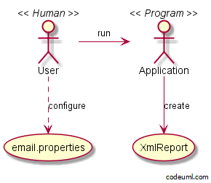

Email Converter is a simple program that reads daily reports from configurable email and converts it into xml files.

Requirements
- At least jdk-1.7
- Apache Maven 3.0.4+

Getting Started
In order to run the program follow these steps:
- git clone
- cd time
- mvn install
- mvn assembly:single
- cd target
- java –jar time-1.0.0-RELEASE.jar

Project in Depth

Detailed diagram

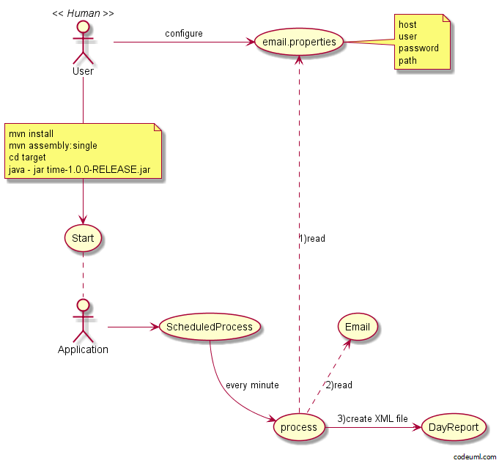

Main Classes
SheduledProcess
When the program starts Spring automatically runs process() method in SheduledProcess class. Process() method would be invoked every minute with a fixed delay, meaning that the period will be measured from the completion time of each preceding invocation.
ReadEmailAndConvertToXmlSpingImpl
Initializing by SheduledProcess class. It loads additional spring configuration. Method execute actually does the entire job: loads email properties, reads email and converts valid ones into xml files.
Email properties are loaded every schedule so you can configure them at any moment by placing email.properties file into the folder with time-1.0.0-RELEASE.jar. Keys are: host, user, password, path. For example, you can put email.properties with body like this:
host=pop.yandex.ru
user=kirill.iliashovitch@yandex.ru
password=godBlessMe
path=D:/XmlReports/
On next schedule program will read from yandex mail service with credentials kirill.iliashovitch@yandex.ru as a user and godBlessMe as a password and will save valid reports at d:/XmlReports/

How to stop the program
You can stop the program just by adding “continue=no” line into your email.properties file. For example, put email.properties file into the folder with time-1.0.0-RELEASE.jar with body like this:
host=pop.yandex.ru
user=kirill.iliashovitch@yandex.ru
password=godBlessMe
path=D:/XmlReports/
continue=no
The program will stop at next schedule.

Testing
Complete module testing with separate configuration.

Logging
Only console messages configure.

